**How does targeted advertising on social media impact the behaviors of Adolescent?**

**What is targeted advertising?**

Targeted advertising is “an advertisement that is served to a specific audience, which could be a particular demographic, a group or an individual” 1, with the intention of directly impacting their consuming behaviors. The group of targeted audience is usually the most receptive group of audiences toward that product or service being advertised. This means that due to certain traits or personal preference, the advertisement is more likely going to appeal to these audience and thus persuade to consume the product being advertised.

**Who are adolescents? What are some symbols of adolescence?**

Generally speaking, adolescents refer to youth between ages of 13 and 19, as we usually call them “teenagers”, or “teens”. Adolescence can be considered as the transitional stage from childhood to adulthood. For the adolescents, it is a period of both disorientation and discovery, usually accompanied by struggling of self-identity and independence. Many adolescents face tough choices regarding school, sexuality, drugs, alcohol, and social life. Their thinking system develops and finalizes during this time, thus any outside factors may contribute to the process of shaping. Social media, for example, has taken up a large part of the adolescents’ life. According to the report by Common Sense Media, a nonprofit organization which focused on helping children learn more about media and technology, "On any given day, American teenagers (13- to 18-year-olds) average about nine hours of entertainment media use, excluding time spent at school or for homework.” When adolescents browse on social medias for hours per day, viewing targeted advertisements is something unavoidable for them. The purpose of this report is to examine the impact that targeted advertising on social media has on adolescents’ behaviors, directly or indirectly.

**How does personalized advertising system function in Social Media?**

­­­­ Before moving on to the impacts of targeted advertisements, we need to know how it function in social media. The two main basis which contribute to functioning of targeted advertisement are Big Data & Algorithm and RTB system.

1. **Big data and algorithm**

Data collection is always the first and most crucial part of targeted advertising. Under no circumstances can a social media accurately offer advertisement without billions of cookies collected from users. Cookies are arbitrary pieces of data, formed when users on internet clicked/browsed on a piece of data on web server, the browser then sends them back to the server. Usually, the web browser company will cooperate with different companies to get enough cookies. The social medias then need advanced algorithm to target users. There are several common algorithms for targeted advertising. The first and simplest way is labelling. A user can be labelled according to their gender, race, age, social status, etc. For instance, a viewer on YouTube can be labelled as “Chinese”, “Female”, “24”, “middle-class”. Then the browser will put on advertisements targeted at a 24-year-old Chinese Women of middle class. ~~Another way is “lookalike modelling”[1] -- finding new people who behave like current users. For instance, users who have watched the same video on YouTube might have common ground. The third way,~~ collaborative filtering recommendation algorithm[2], is also frequently used in Social media. This algorithm helps social medias give recommendation according to their browsing history and transaction information.

1. **RTB advertising system**

One of the most advanced and commonly used programmatic advertisings will be focused on to help you gain an overview of how targeted advertising systems usually function. The very type of system is known as RTB, Real-Time Bidding. Emerging in 2009[3], RTB, different from other advertising systems like CPC (Cost Per Click), CPM (Cost Per Mille) or CPA (Cost Per Action), is a system that uses bidding to determine the price of an advertisement for certain frequency cap, meaning that every time before an advertisement is delivered, there will be a bidding process between different advertisers. The bidding will be completed within 100 milliseconds. This system guarantees the efficiency as well as the accuracy of advertisement delivery.

RTB advertising system is mainly composed of six elements: publisher, advertiser, SSP (Supply Side Platform), AD exchange, DSP (Demand Side Platform), DMP (Data Management Platform).

Figure 1: a brief illustration of RTB Yuan, Shuai, et al. Real-Time Bidding for Online Advertising: Measurement and Analysis.

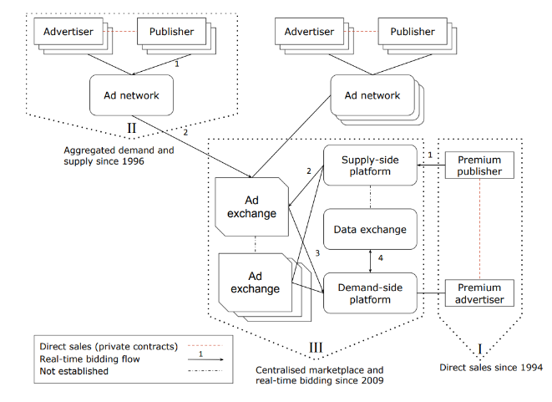Take YouTube as an example. A user is browsing YouTube. Now YouTube is SSP in this case. And YouTube can send all the related information about the user to AD exchange, and AD exchange will then send the information to DSP. DSP will filter the information of advertisers and publisher, and calculate the value of the advertisement opportunity provided by YouTube and send the value to possible advertisers. Supposed the advertisers are A, B and C, and the bidding prices are P1, P2 and P3, respectively. If P2 is the largest among the bidding prices, then B, the advertiser with the top offer, will get the advertising opportunity.

**What is the impact of targeted advertisement?**

The functioning of targeted advertisement is based completely on the concept of demand and supply. A supply is needed when something is demanded by the consumer, and the purpose of targeted advertisement is to put a source of supply in front of the consumers, appeal to their demand, and lead them to think that they made the choice of buying the object by themselves when in reality, the decision was an involuntary one constructed by the seller of products and social media.

Negative impacts:

It is showed that targeted advertisement of unhealthy products, including junk food, cigarettes and alcohol, is linked directly to various negative outcomes for youth. For example, “youth exposure to television advertising for electronic cigarettes doubled from 2011 to 2013”. Furthermore, a meta-analysis found that “advertising and other media portrayals depicting the thin-ideal for women are related to a negative body image among women and girls”

* Personalized emails improve clickthrough rates by 14%
* In a study of more than 93,000 calls-to-action created using HubSpot, and hundreds of millions of views over a 12-month period, HubSpot found that calls-to-action targeted to the user had a 42% higher view-to-submission rate than calls-to-action that were the same for all visitors.
* The average young person growing up in the United States sees anywhere from 13 000 to 30 000 advertisements on television each year

^ advertising to children and adolescents has become ubiquitous

* Buijzen M, Valkenburg PM. The effects of television advertising on materialism, parent-child conflict, and unhappiness: a review of research. J Appl Dev Psychol. 2003;24(4):437-456 Grabe S,
* Ward LM, Hyde JS. The role of the media in body image concerns among women: a meta-analysis of experimental and correlational studies. Psychol Bull. 2008;134(3):460-476pmid:18444705

1. Hayter, Luke. “Lookalike Modelling: the Ad Industry Technique Demystified.” *The Guardian*, Guardian News and Media, 6 Sept. 2013, www.theguardian.com/media-network/media-network-blog/2013/sep/06/lookalike-modelling-advertising-demystified.
2. Sarwar, Badrul, et al. *Item-Based Collaborative Filtering Recommendation Algorithms*. 2001, *Item-Based Collaborative Filtering Recommendation Algorithms*, www.ra.ethz.ch/cdstore/www10/papers/pdf/p519.pdf.
3. Yuan, Shuai, et al. *Real-Time Bidding for Online Advertising: Measurement and Analysis*. 2013, arxiv.org/pdf/1306.6542.pdf.